**Cumulative distribution function:**

A cumulative probability refers to the probability that the value of a [random variable](https://www.stattrek.com/Help/Glossary.aspx?Target=Random_variable)falls within a specified range. Frequently, cumulative probabilities refer to the probability that a random variable is less than or equal to a specified value.

Cumulative probability is always between 0 to 1, in given below fig, if we need to find the probability of point below or equal to 0.4, then we can say this by using cdf as in below it’s 0.8 probability or 80%.

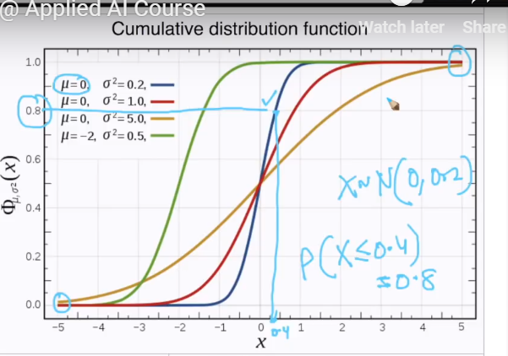

At mean the probability of density is just half (50%) of total.

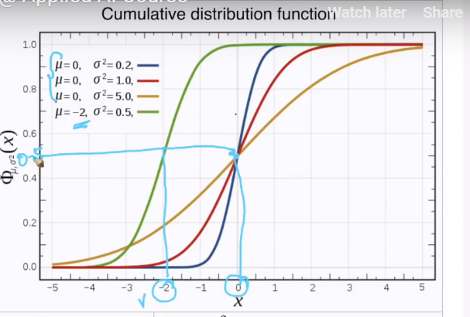

The cdf curve get farther and farther away from the perpendicular line at mean(shown in light blue color), as the variance increases.

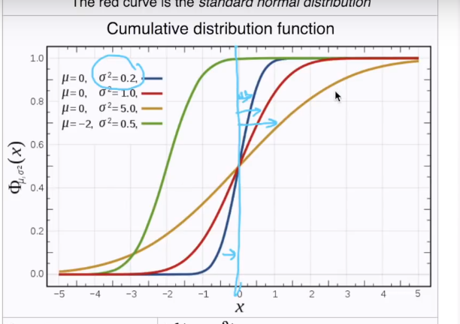

**68-95-99.7 Rule:**

If given X (dataset) which follows Normal/gaussian distribution with mean 0 and variance 4, ie SD is 2.

Now just by seeing the below graph, we can say that

* 68.2% of population lies between -1*SD to +1SD.
* 95% of population lies between -2*SD to +2SD
* 99.7% of population lies between -3*SD to +3SD.

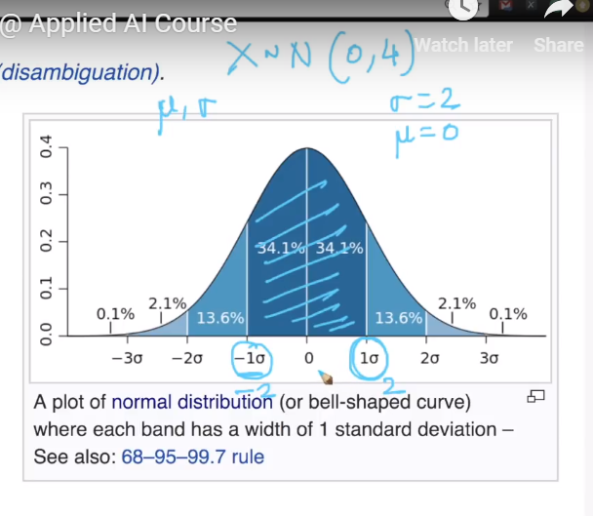

Ex: let’s say we have given weights (X) with mean 150 and SD 25, then directly we can give following informations

1. 68.2% of population lies between 125-175;
2. 95% of population lies between 100-200;
3. 99.7% of population lies between 75-225;

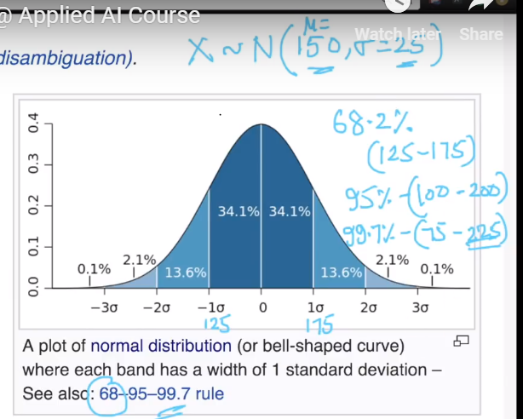

Some Comments:

* Since the PDF of a gaussian RV is symmetric about its mean does the mean and median of it are same? Please discuss.

Yes, The mean, median, and mode of a normal distribution are equal. This is also true for any symmetrical distribution.